Write a Python function that accepts a string and calculates the number of uppercase letters and lower case letters.

def test(s):

up=0

loo=0

for c in s:

if c.isupper():

up+=1

elif c.islower():

loo+=1

print ("Original String : ", s)

print ("No. of Upper case characters : ", up)

print ("No. of Lower case Characters : ", loo)

test("A Spoonfull of Sugar")

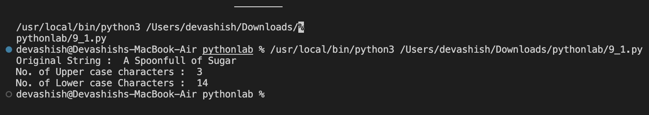

**2. Write a Python function that checks whether a passed string is palindrome or not.   
Note: A palindrome is a word, phrase, or sequence that reads the same backward as forward, e.g., madam or nurses run.**

def test(s):

f=0

for i in range(0,len(s)//2):

if s[i]!=s[len(s)-1-i]:

f=1

break

if f==0:

print(f"{s} is palindrome!")

else:

print(f"{s} is not palindrome!")

test("malayalam")

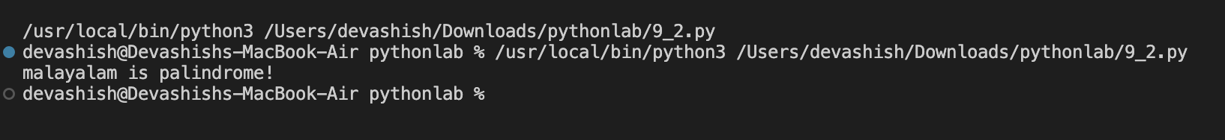

Q3. Write a Python function to check whether a string is a pangram or not.   
Note : Pangrams are words or sentences containing every letter of the alphabet at least once.  
For example : "The quick brown fox jumps over the lazy dog"

import string

def pangram(str):

fl=0

alpha = "abcdefghijklmnopqrstuvwxyz"

for i in alpha:

if i not in str.lower():

fl=1

break

if fl==0:

print(f"::{str } ::Is pangram")

else:

print("Is not pangram")

stri= 'the quick brown fox jumps over the lazy dog'

pangram(stri)

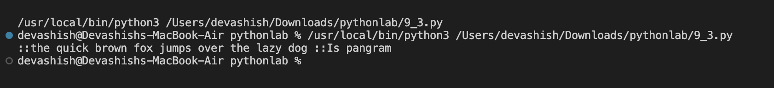

Q4. Write a Python program to detect the number of local variables declared in a function.

**def uae( hu):**

**abu_dhabi = 23**

**dubai=974**

**s_zayed=978**

**print(uae.__code__.co_nlocals)**

